CISS 120 Skills Based Assessment – Creating a Small Network
These are the directions for the lab for 2016 CISS. The lab is a Packet Tracer Activity file (.pka) and is provided seperately. You may work with other students on this lab if you wish, but each student should submit a separate lab that should reflect the indivdual’s understanding. you are working to establish full connectivity between all devices and interfaces. Enjoy, and good luck!
Topology
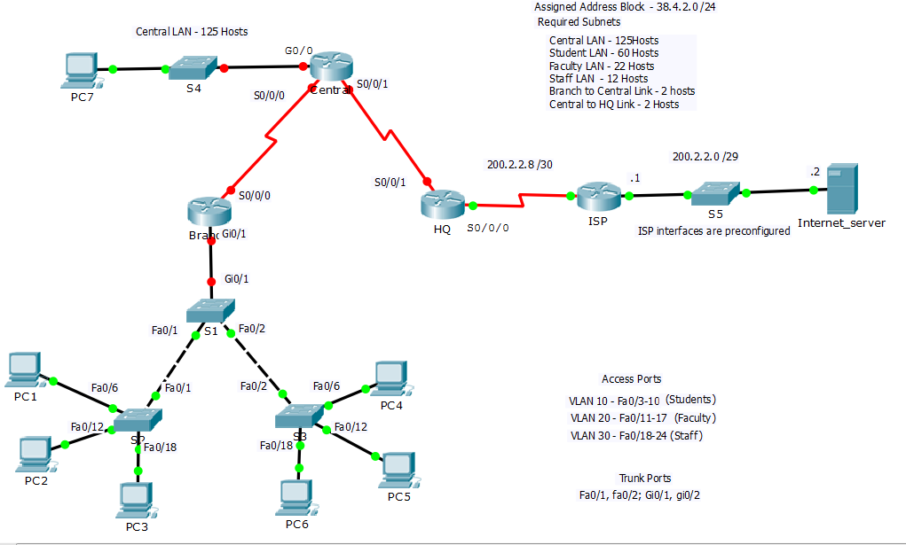
Overview
In this lab you will be building a small network, and your tasks will include subnetting, configuration of the routers, switches and PCs, VLANs, InterVLAN routing, static routing, and dynamic routing using OSPF. The lab is divided into four sections, as follows:
- Network Design (15 points) - subnetting a /24 network
- Basic Configuration Tasks (20 points) - includes hostnames, interfaces, and default gateways
- Configure the Branch LANs (25 points) - configuring switchports, VLANs, and InterVLAN routing
- Configure Static and Dynamic Routing (40 points)

Step 1. Network Design (15 points)
You will be creating the networks for the 4 LANs and the two internal point-to-point networks. You are given the 38.4.2.0/24 network to work with.
First create the Central LAN network, which will need to support 125 hosts. The second network will be the R1 Student LAN (VLAN 10), and will need to support 60 hosts. The third network will be the Faculty LAN (VLAN 20), which will need to support 22 hosts. The fourth networks will be the Staff LAN (VLAN 30) which will require 12 hosts. The fifth and sixth networks will be used to for the serial point-to-point links, and will each support 2 hosts. Note that there will be a small amount of unused address space when you have completed your subnetting.
For the LANs, assign the first usable address to the router interface, and the second to the PCs. For the Central LAN, you will also be assigning the last assignable address to switch S4 VLAN 1 interface. I recommend that you fill out the following table to keep things straight, but the table will not need to be submitted.
Final Lab – Addressing Table
Device/Interface | IP Address | Network Mask | Default gateway
Central Gi0/1 |  |  | n/a
Central S0/0/0 |  |  | n/a
Central S0/0/1 |  |  | n/a
Branch Gi0/1.10 |  |  | n/a
Branch Gi0/1.20 |  |  | n/a
Branch Gi0/1.30 |  |  | n/a
Branch S0/0/0 |  |  | n/a
HQ S0/0/1 |  |  | n/a
HQ S0/0/0 | 200.2.2.9 (preconfigured) | 255.255.255.252 | n/a
PC1 (VLAN 10)
PC2 (VLAN 20)
PC3 (VLAN 30)
PC4 (VLAN 10)
PC5 (VLAN 20)
PC6 (VLAN 30)
PC7
Switch S4

Basic Configuration Tasks (20 points)
Configure the hostnames on all routers and switches, as shown in the topology
Configure the serial interfaces for Branch, Central, and HQ according to your addressing table, and verify point-to-point connectivity.
Configure the Central LAN (PC3, Switch S4 and Central Gi0/1) with the appropriate addresses and mask, and verify connectivity from the PC and the switch to the default gateway.
Configure the Branch LANs (25 points)
Create VLANs 10, 20 and 30 on all three switches, naming VLAN 10 Students, VLAN 20 Faculty, and VLAN 30 Staff. For all three switches, configure ports fa0/3 to fa0/24 as access ports. Assign ports fa0/3 to fa0/10 to VLAN 10, ports Fa0/11 to fa0/17 to VLAN 20, and fa0/18 to fa0/24 to VLAN 30.
Configure ports fa0/1-fa0/2 and Gi0/1-G0/2 as trunk ports on all three switches.
On router Branch, configure interface Gi0/1 with three subinterfaces to provide InterVLAN routing for VLANs 10, 20, and 30. Assign the first assignable addresses in each of the Branch LANs to their subinterfaces. Turn up the physical interface. Verify all the PCs can ping their respective default gateways. Verify InterVLAN routing between PC1 and PC2
Configure Static and Dynamic Routing (40 points)
You will be configuring dynamic routing between HQ, Central, and Branch using OSPF. For each router, begin by entering router ospf configuration mode with process id 1, and assign OSPF router-ids as follows: Branch should be assigned 1.1.1.1. Central should be 2.2.2.2, and HQ should be 3.3.3.3.
Next, enable all interfaces on Branch and Central and the S0/0/1 on HQ in area 0 with the OSPF network command. The HQ S0/0/0 interface will not be enabled is OSPF since you will be doing static routing with the ISP. Use the correct wild card mask for each network (recall that the wildcard mask can be determined by subtracting the subnet mask from the 255.255.255.255. For example, a /30 network has a 255.255.255.252 network mask, and subtracting that from the 255.255.255.255 gives a wildcard mask of 0.0.0.3 for a /30 network). When you have correctly complete these tasks you should see OSPF routes in the routing tables, and OSPF adjacencies when you enter the show ip ospf neighbor command.
To complete the routing, you must configure two static routes. First, create a static default on HQ pointing to the ISP router (S0/0/0). Redistribute the static default to the OSPF domain with the OSPF configuration command default-information originate. Secondly, create a static route on the ISP router to the 38.4.2.0 /24 network, pointing to the S0/0/0 interface. If these are correctly configured, and your OSPF configuration is working, you should now have full connectivity between all hosts, servers, and router interfaces.
Verify correct operation
Before submitting, verify that each PC can ping all the other PCs and the Internet server.

In this part you will be subnetting the 38.4.2.0 /24 network to create six smaller networks. The first will be the Central LAN network, which will need to support 125 hosts. The second network will be the R1 Student LAN (VLAN 10), and will need to support 60 hosts. The third network will be the Faculty LAN (VLAN 20), which will need to support 22 hosts. The fourth networks will be the Staff LAN (VLAN 30) which will require 12 hosts. The fifth and sixth networks will be used to for the serial point-to-point links, and will each support 2 hosts. Note that there will be a small amount of unused address space when you have completed your subnetting. Document your networks in the table below.

Addressing Table
Network | Network Address | Network Mask | First Usable Address | Second Usable Address
Central LAN (125 hosts)
Student LAN (VLAN 10 – 60 hosts)
Faculty LAN (VLAN 20-22 hosts)
Staff LAN (VLAN 30 – 12 hosts)
Branch-to-Central Link (2 hosts)
Central-to-HQ Link (2 hosts)

Assigning Addresses
For the LANs, assign the first usable address to the router interface, and the second to the PCs. For the Central LAN, you will also be assigning the last assignable address to switch S4 VLAN 1 interface. I recommend that you fill out the following table to keep things straight, but the table will not need to be submitted.
Addressing Table
Device/Interface | IP Address | Network Mask | Default gateway
Central Gi0/1 (Central LAN) |  |  | n/a
Central S0/0/0 (Central to Branch) |  |  | n/a
Central S0/0/1  (Central to HQ) |  |  | n/a
Branch Gi0/1.10 (Student VLAN) |  |  | n/a
Branch Gi0/1.20 (Faculty VLAN) |  |  | n/a
Branch Gi0/1.30 (Staff VLAN) |  |  | n/a
Branch S0/0/0 (Branch to Central) |  |  | n/a
HQ S0/0/1 (HQ to Central) |  |  | n/a
HQ S0/0/0 (HQ to ISP) | 200.2.2.9 (preconfigured) | 255.255.255.252 | n/a
PC1 (VLAN 10)
PC2 (VLAN 20)
PC3 (VLAN 30)
PC4 (VLAN 10)
PC5 (VLAN 20)
PC6 (VLAN 30)
PC7
Switch S4

